**Title** : **AI-powered Nutrition Analyzer for Fitness Enthusiasts**

**Team Size :** 5

**Team Leader :**SOORAJ K

**Team member :** RAM BALAJI

**Team member :**PRASSANA KUMAR

**Team member :** PRAVEEN RAJ S

**Team member :** RITHVIK THOTA

2.3 Prepare Empathy Map Canvas to capture the user Pains & Gains, Prepare List of problem statements

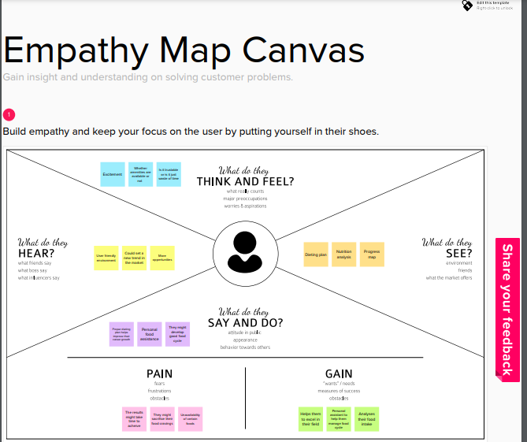



2.4 Attend the technology trainings as per the training calendar

Attended the training session.